ردیف | Name | Department
 | 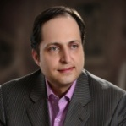  Prof. Hassan Soleimanpour; MD (Head) | Emergency
 | 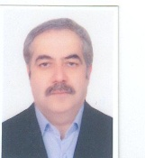  Prof. Sohrab Negargar; MD | Anesthesiology
 | 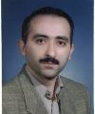  Prof. Samad Gaffari; MD | Cardiology
 | 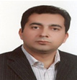  Prof. Hormoz Airemlou; MD | Neurology
 | 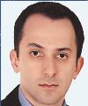  Prof. Ata Mahmoodpoor; MD | Anesthesiology
 | 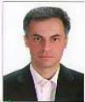  Dr. Ali Tagizadieh; MD | Internal medicine
 | 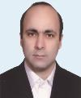  Dr. Kamran Shadvar; MD | Anesthesiology
 | 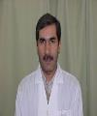  Dr. Alireza Sadegpoor; MD | Orthopedic
 | 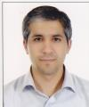  Dr. Hadi Hamishekar | Pharmacotherapy
 | 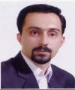  Dr. Alireza Ala; MD | Emergency
 | 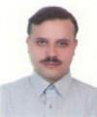  Dr. Seyed Hosein Ojaghi; MD | Emergency
 | 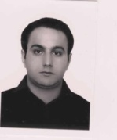  Dr. Reza Rikhtegar; MD | Neurology
 | 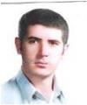  Dr. Faezad Rahmani ; MD | Emergency
 | 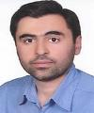  Dr. Ali Golmohammadi; MD | Cardiology
 | 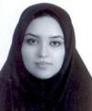  Dr. Leili Pourafkari; MD | Cardiology
 | 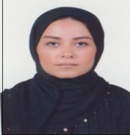  Dr. Sarvin Sanaee; MD | Aging Institute

